APPLIED CRYPTOGRAPHY

**Lab 8 : OpenSSL Lab**

Name: Siri N Shetty SRN: PES2UG22CS556

**Problem 1: OpenSSL from the command line**

Step 1 : Run the 4 commands

Expected Deliverables -   
i) Output Screenshot (Terminal should have SRN visible) for step 1 showing the 4 cmds

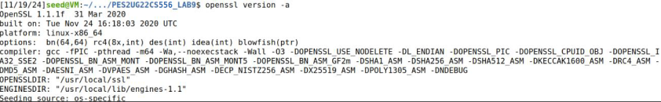

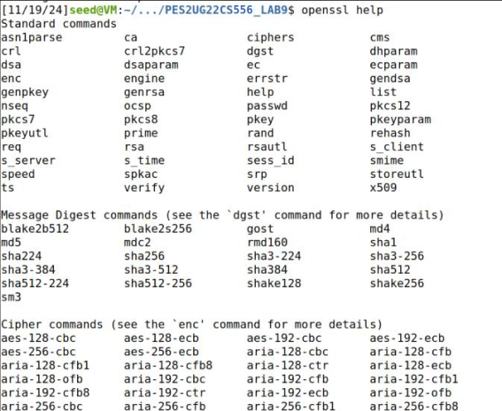

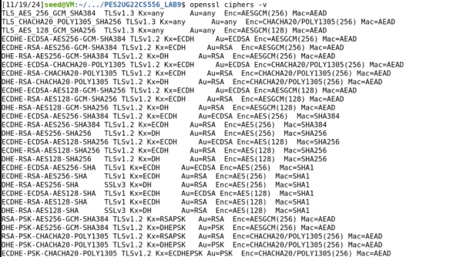

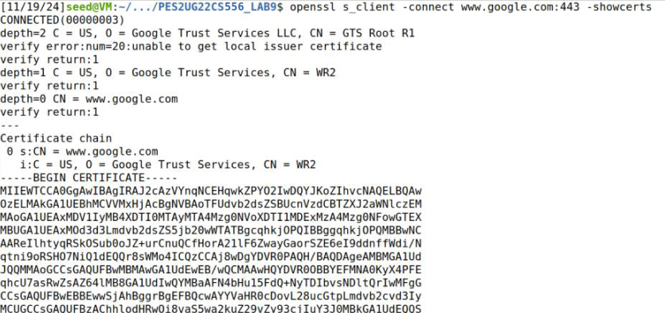

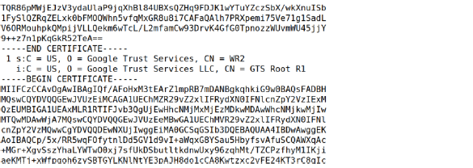

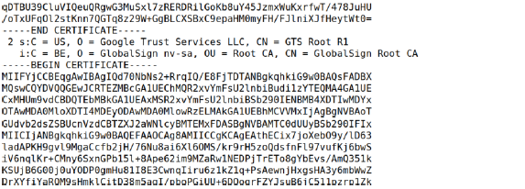

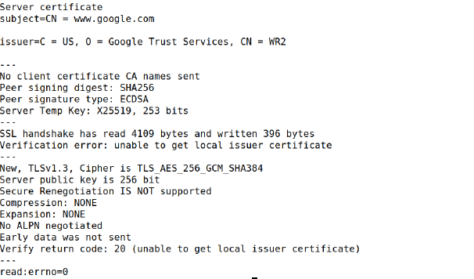

**Problem 2 : Generating Keys**

Step 1 : Run the cmd to generate a 2048-bit RSA key

Step 2 : Run the cmd to generate a 256-bit ECC key

Expected Deliverables -   
i) Output Screenshot (Terminal should have SRN visible) for step 1

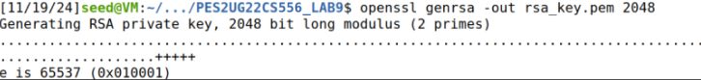

ii) Output Screenshot (Terminal should have SRN visible) for step 2

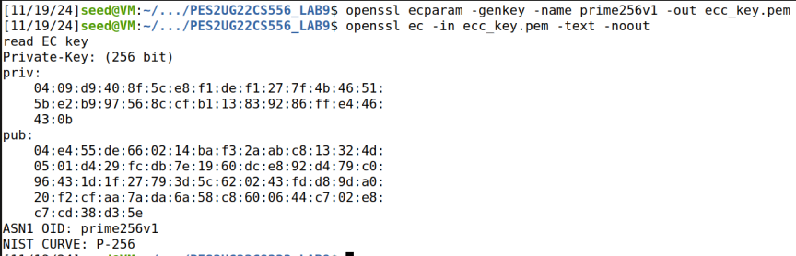

**Problem 3 : Encrypting and Decrypting Data**

Step 1 : encrypt data using aes-256-cbc

Step 2 : decrypt data using aes-256-cbc

Step 3 : perform encryption and decryption using diff algorithm

Step 4 : implement password prompt

Step 5 : batch encryption

Expected Deliverables -   
i) Output Screenshot (Terminal should have SRN visible) for step 1



ii) Output Screenshot (Terminal should have SRN visible) for step 2.



iii) Output Screenshot (Terminal should have SRN visible) for step 3



iv) Compare the results and understand the differences in security and

performance.

Security:

1. AES-256-CBC uses a 256-bit key length, offering stronger theoretical security
2. AES-128-CBC uses a 128-bit key length, which is considered cryptographically secure for most applications
3. The 256-bit version has a higher security margin against future quantum computing attacks.

Performance:

1. AES-128-CBC generally performs faster as it uses fewer rounds (10 rounds vs 14 rounds in AES-256)
2. Lower computational overhead with 128-bit, making it more efficient for resource-constrained systems
3. Memory usage is slightly lower with 128-bit encryption

v) Output Screenshot (Terminal should have SRN visible) for step 4

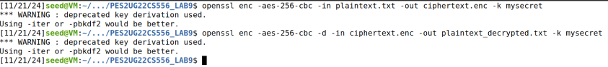



vi) Code for step 5

#!/bin/bash

# Directory containing the files to encrypt

SOURCE_DIR="files_to_encrypt"

DEST_DIR="encrypted_files"

# Password for encryption

PASSWORD="mysecret"

# Create destination directory if it doesn't exist

mkdir -p "$DEST_DIR"

# Encrypt each file

for FILE in "$SOURCE_DIR"/*; do

FILENAME=$(basename "$FILE")

openssl enc -aes-256-cbc -in "

$FILE" -out "$DEST_DIR/$FILENAME.enc" -k "$PASSWORD"

echo "Encrypted: $FILENAME"

done

vii) Output Screenshot (Terminal should have SRN visible) for step 5

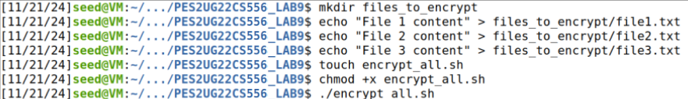

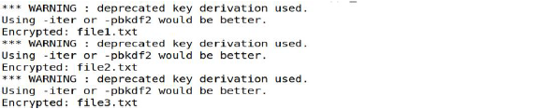



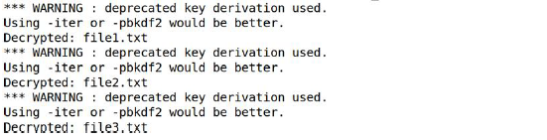

**Problem 4 : Generating Certificates**

Step 1 : Run the cmd to create a self-signed certificate

Step 2 : Run the cmd to generate a CSR

Expected Deliverables -   
i) Output Screenshot (Terminal should have SRN visible) for step 1

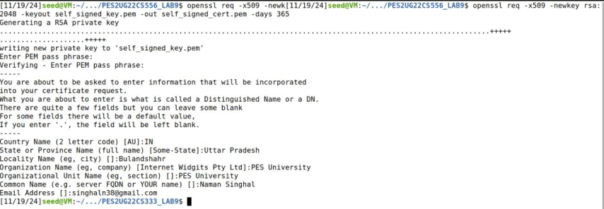

ii) Output Screenshot (Terminal should have SRN visible) for step 2

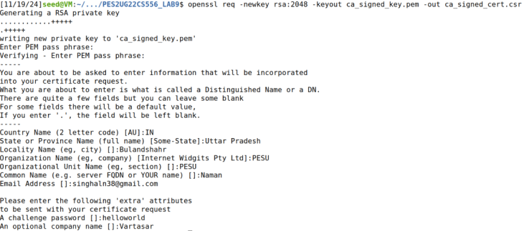



**Problem 5 : OpenSSL create self-signed certificate**

Step 1a : Create encrypted password file

Step 1b : Show decryption of password file

Step 2a : Create new directory to store certificate

Step 2b : Copy the encrypted password file to /root/certs

Step 3 : Generate private key

Step 4 : Create CSR

Step 5 : Create self-signed certificate using openssl x509

Step 6 : Show the contents of the files

Expected Deliverables -   
i) Output Screenshot (Terminal should have SRN visible) for step 1





ii) Output Screenshot (Terminal should have SRN visible) for step 2

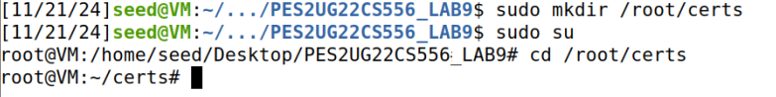



iii) Output Screenshot (Terminal should have SRN visible) for step 3

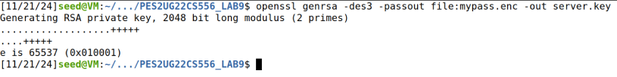

iv) Output Screenshot (Terminal should have SRN visible) for step 4

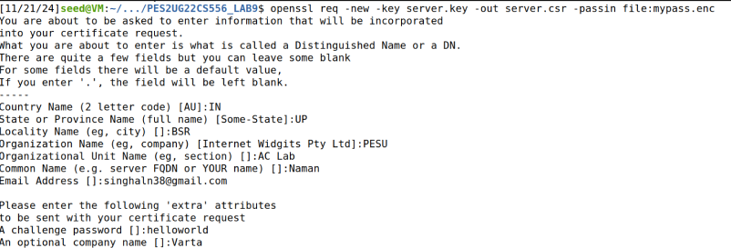

v) Read and explain the use of -passout and -passin option.

1. -passout (Password Output):
   1. Used when creating/encrypting files that need a password
   2. Specifies how to generate or obtain the password for encryption
2. -passin (Password Input):
   1. Used when reading/decrypting password-protected files
   2. Specifies how to obtain the password for decryption

vi) Output Screenshot (Terminal should have SRN visible) for step 5



vii) Output Screenshot (Terminal should have SRN visible) for step 6

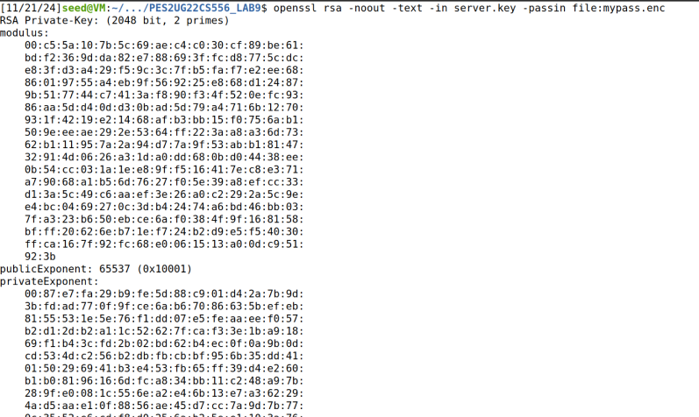

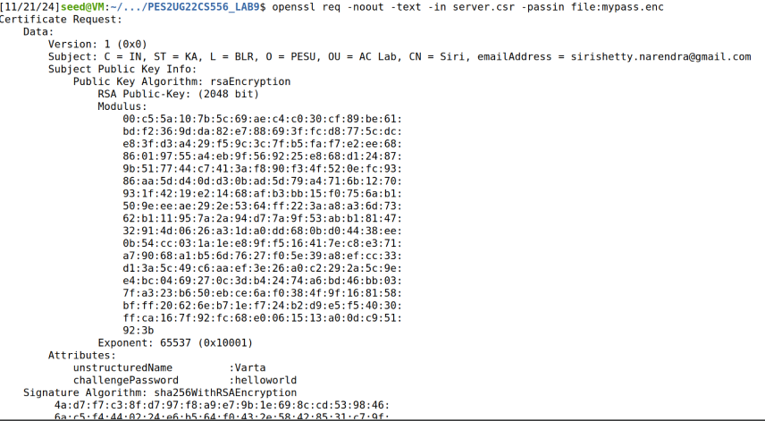

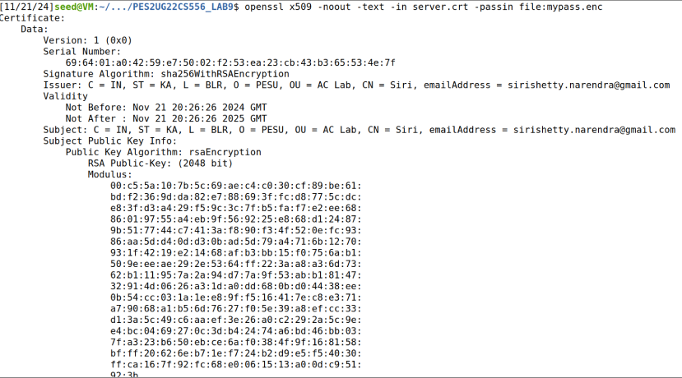

**Problem 6 : Certificate Validity Check Using OpenSSL**

Step 1 : perform prerequisites and run the cmd to verify validity

Expected Deliverables -   
i) Output Screenshot (Terminal should have SRN visible) for step 1



ii) Why is it important to verify the validity of a certificate before trusting it in a secure communication setup?

Verifying a certificate is crucial because it:

1. Authenticates Identity:   
   Confirms the entity you’re communicating with is genuine.
2. Ensures Data Integrity:   
   Prevents tampered or fake certificates from being used.
3. Enables Secure Encryption:   
   Validates strong encryption for safe communication.
4. Checks Revocation/Expiration:   
   Ensures the certificate is still valid and not revoked.
5. Prevents Attacks:   
   Protects against Man-in-the-Middle attacks and unauthorized access.

Failure to verify can lead to data breaches, impersonation, and loss of trust in secure communications.

iii) What are some common reasons for certificate verification failures, and how can they be addressed?

Certificate verification failures occur due to expiration, revocation, mismatched CN, untrusted CAs, or incomplete chains. Solutions include renewing certificates, configuring chains correctly, and ensuring secure algorithms and accurate system time.

iv) How can you obtain a trusted CA certificate or bundle in real-world scenarios?

To obtain a trusted CA certificate or bundle:

1. Certificate Authority (CA): Purchase or get a free certificate from trusted CAs like DigiCert, Let's Encrypt, or GlobalSign.
2. Operating System or Browser Trust Stores: Use pre-installed CA certificates in your system or browser.
3. Let's Encrypt: Obtain free certificates using tools like Certbot.
4. Public Repositories: Download trusted CA certificates from repositories like Mozilla.
5. Self-Signed for Internal Use: Create your own CA for internal certificates.
6. CA Bundles: CAs often provide a bundle of root and intermediate certificates for full trust validation.

**Problem 7 : Testing TLS Connections**

Step 1 : test a TLS connection

Step 2 : Modify the openssl s_client command to check if the

server's certificate is valid

Step 3 : Use OpenSSL to list the supported cipher suites by the server.

Step 4 : Try connecting to the server using different TLS/SSL protocols, such as TLS 1.2 and TLS 1.3.

Expected Deliverables -   
i) Output Screenshot (Terminal should have SRN visible) for step 1

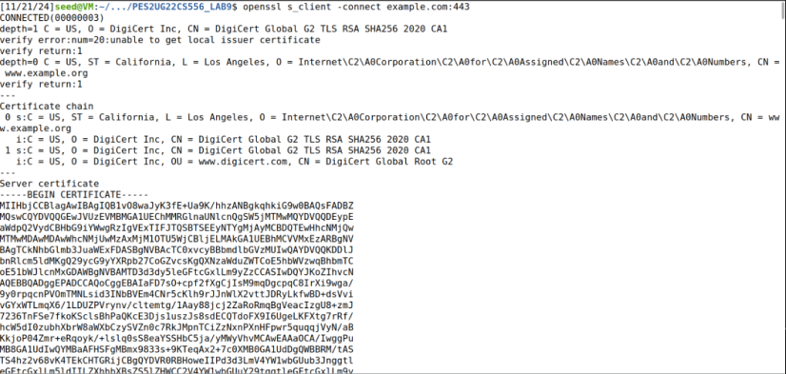

ii) Output Screenshot (Terminal should have SRN visible) for step 2

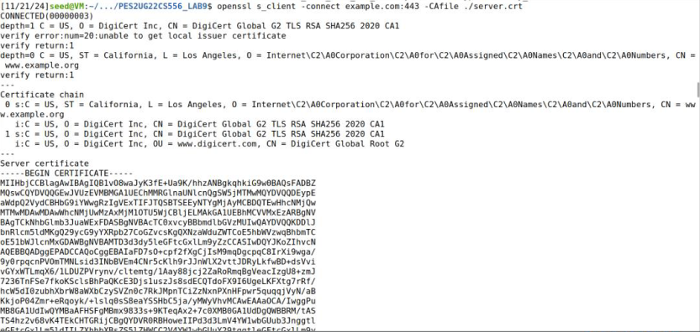

iii) Explain the significance of verifying the certificate's authenticity.

Verifying a certificate's authenticity ensures that you are communicating with the legitimate server and not an imposter. It prevents Man-in-the-Middle (MITM) attacks, ensures data integrity, and authenticates the server's identity. A valid certificate builds trust, helps meet security compliance standards, and protects against phishing and fraud. It guarantees that the data exchanged is secure and not tampered with

iv) Output Screenshot (Terminal should have SRN visible) for step 3

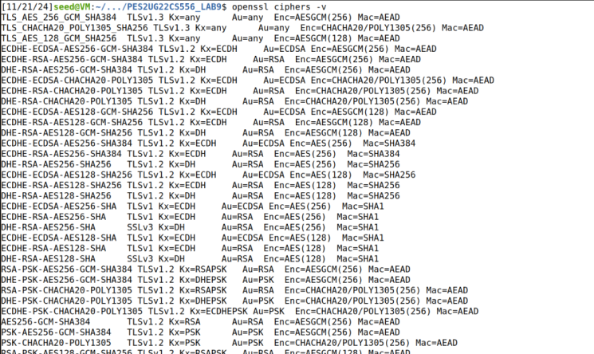

v) Discuss the importance of selecting strong cipher suites for security.

Selecting strong cipher suites is essential for ensuring secure encryption, data integrity, and authentication. Strong suites protect against modern attacks, such as brute force and MITM attacks, and ensure compliance with security standards. They also future-proof your systems by using cryptographically secure algorithms, preventing vulnerabilities from outdated encryption methods.

vi) Output Screenshot (Terminal should have SRN visible) for step 4

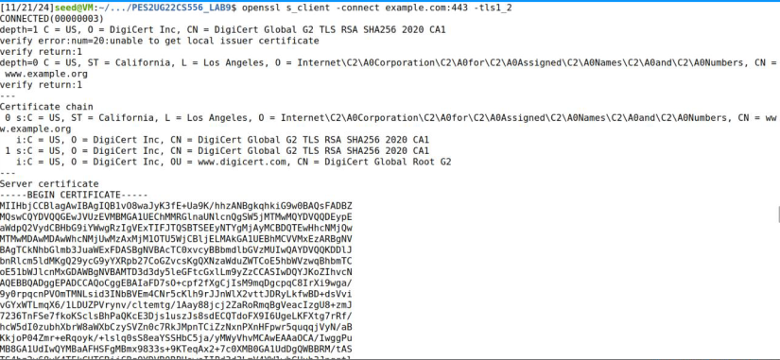

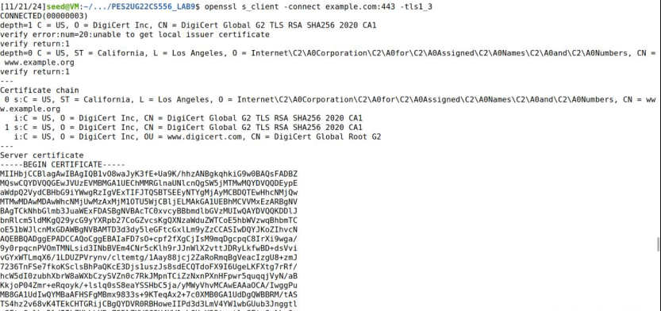

vii) Compare the results and identify the protocol versions supported by the server.

1. If the server supports TLS 1.2, you will see "TLSv1.2" in the protocol line of the output.
2. If the server supports TLS 1.3, you will see "TLSv1.3" in the protocol line of the output.
3. If the server does not support a version, the command will either fail to connect or show an "unknown protocol" error.

Conclusion:

TLS 1.3 is the more modern and secure version, and it should be prioritized over TLS 1.2. Servers that support both versions are more flexible and secure, but using TLS 1.3 is recommended for better encryption and performance.

**Problem 8 : Troubleshooting Security Problems**

Step 1 : Collect info about connection debug cmd

Expected Deliverables -   
i) Output Screenshot (Terminal should have SRN visible) for step 1

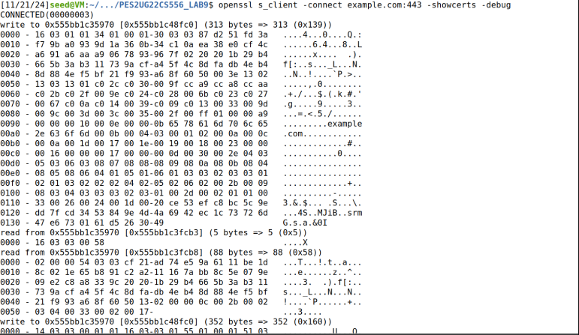

ii) Explain your observation

The OpenSSL s_client -connect hostname:port -showcerts -debug command helps troubleshoot TLS connection issues by providing detailed information:

1. Server Certificate: Displays the server’s certificate, helping verify its validity, expiration, and trustworthiness (e.g., if the CA is trusted).
2. Cipher Suite: Shows the encryption algorithms used. Weak cipher suites can indicate vulnerabilities, so stronger suites like AES-256 should be used.
3. TLS Handshake: Logs details of the handshake, showing if there are version mismatches or unsupported cipher suites that could cause connection issues.
4. Connection Issues: If the connection fails, it will show errors like "connection refused" or "handshake failure," helping identify server unavailability or configuration issues.
5. Certificate Validation Failures: If the certificate has problems (expired, self-signed, or hostname mismatch), the output will indicate these issues, pointing to what needs fixing. In short, this command helps diagnose certificate, cipher suite, and handshake issues, ensuring a secure and functional TLS connection

Submission Format : SRN_Name_Lab8_AC.pdf